** DHA Suffa University Karachi**

**Department of Basic Sciences**

**Basic Electronics Lab**

**Spring 2020**

**Quiz**

BS-1102L DATE: 24 june 2020

Name: Poorab Gangwani Class & Section : 2B1

Enrollment # CS191092

Course Instructor: Sidra Malik Max. Marks 05

Q1. Develop the circuiton the software (multisim) and find out the ripple factor.

Diode: 1BH62

Load: 4K

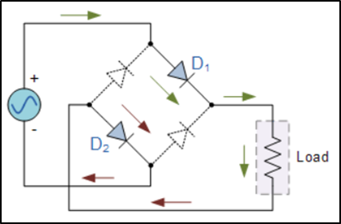

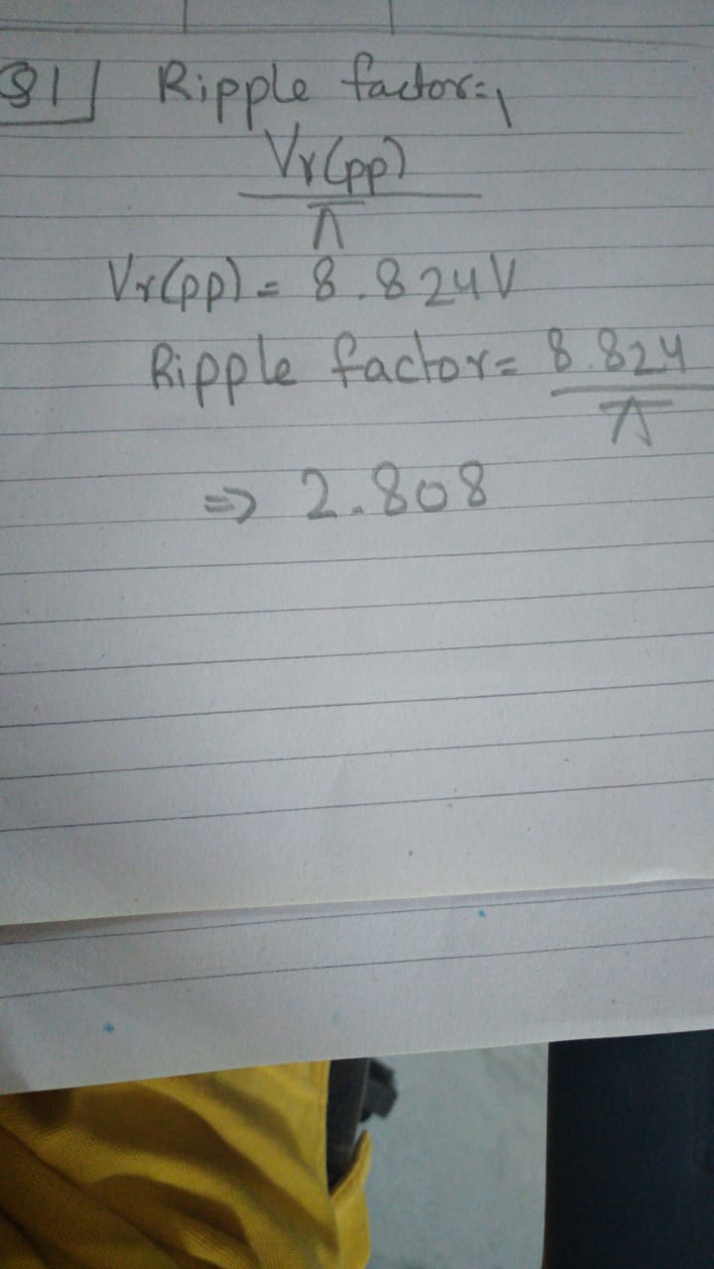

Q2. Design the circuit on the multisim.

Diode:1N3600

Increase the voltage of the voltage source (V1) from 0V to 5V in steps of 1V. For each Observation, record the current (If) flowing through the circuit and the voltage drop (Vf) across the diode.

